9.6 Model validation

Final step in the model building process is validation of the selected regression model.

Why does KNN put this section in Chapter 9 if it is the “last step”? I am not for sure! The section used to be after all of Chapter 10, which probably is its better place!

Methods:

- Collect new data (preferred method)

  - Re-estimate the model parameters on the new data set

Compare how close the parameter estimates are from the old and new data sets. If parameter estimates are close, then the model is fine.

  - Measure the predictive capability of the model on the new data set.

Use the mean squared prediction error (MSPR):
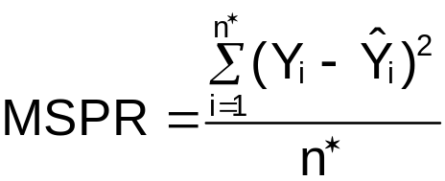

where
Y_{i} is response variable from the new data set
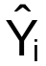 is the predicted Y_{i} value (use original model b_{j}'s)
n* is the number of observations in the new data set

If MSPR is relatively close to MSE, then the model is fine. If MSPR is much larger than MSE, then MSE is a biased estimate of σ².

  - Examine semi-studentized residuals for the new data set to check for outliers.

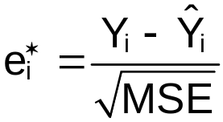

where
Y_{i} is response variable from the new data set
is the predicted Y_{i} value (use original model b_{j}'s)
MSE is the mean square error calculated on the original data set

This can help detect observations that are not being predicted adequately by the model.

- Use a holdout sample (also called data splitting)

Since collecting new data is often not feasible, the original data set is often split into “model building” and “validation” data sets.
- Model building data set – Used to construct the model upon. Also referred to as a “training” data set in other statistical applications.
- Validation data set – Used to evaluate the model. Also referred to as a “test” data set in other statistical applications.

Notes:
    - The data set needs to be split at beginning of the model building process.
    - Want the model building data set to be as large as possible so that good estimates of the parameters and their standard errors can be obtained
    - Want the validation data set to be large enough so that enough data is available to evaluate the model
    - KNN recommends having a number of observations at least 6 to 10 times the number of predictor variables in the variable pool for the model building data set.
    - Other recommendations that I have seen are using 80% in the model building and 20% in the validation.
    - The data set needs to be randomly split so that no biases are introduced into the model building process.
    - The validation set can be treated in the same way as a new data set – see 1).

Example: NBA guard data (NBA_ch10_validation.R)

Additional data was collected for the 1998-9 season. Note that it would be preferable to have data from the 1992-3 season. However, as is frequently the case with sports data, one would like to make statements about future seasons using a model based on past data so this is a good data set to use for model validation.

> #1992-3 data
> nba<-read.table(file =
"C:\\chris\\UNL\\STAT870\\Chapter6\\nba_data.txt",
header=TRUE, sep = "")
> head(nba)
last.name first.initial games PPM MPG height FTP FGP age
1 Abdul-Rauf M. 80 0.5668 33.8750 185 93.5 45.0 24
2 Adams M. 69 0.4086 36.2174 178 85.6 43.9 30
3 Ainge D. 81 0.4419 26.7037 196 84.8 46.2 34
4 Anderson K. 55 0.4624 36.5455 185 77.6 43.5 23
5 Anthony G. 70 0.2719 24.2714 188 67.3 41.5 26
6 Armstrsong B.J. 81 0.3998 30.7654 188 86.1 49.9 26

> #Model chosen on 1992-3 data
> mod.fit<-lm(formula = PPM ~ MPG + height + FGP + age +
I(MPG^2) + MPG:age, data = nba)
> sum.fit<-summary(mod.fit)
> sum.fit

Call:
lm(formula = PPM ~ MPG + height + FGP + age + I(MPG^2) +
MPG:age, data = nba)
Residuals:
Min 1Q Median 3Q Max
-0.176248 -0.060386 -0.006655 0.059309 0.186663

Coefficients:
Estimate Std. Error t value Pr(>|t|)
(Intercept) -2.654e-01 2.847e-01 -0.932 0.353570
MPG -3.940e-02 7.657e-03 -5.146 1.37e-06 ***
height 4.821e-03 1.189e-03 4.056 0.000100 ***
FGP 1.096e-02 2.048e-03 5.350 5.76e-07 ***
age -2.277e-02 6.629e-03 -3.436 0.000869 ***
I(MPG^2) 3.952e-04 9.821e-05 4.024 0.000113 ***
MPG:age 8.752e-04 2.838e-04 3.084 0.002651 **
---
Signif. codes: 0 '***' 0.001 '**' 0.01 '*' 0.05 '.' 0.1 ' ' 1

Residual standard error: 0.08447 on 98 degrees of freedom
Multiple R-Squared: 0.4993, Adjusted R-squared: 0.4687
F-statistic: 16.29 on 6 and 98 DF, p-value: 6.285e-13

> #1998-9 data
> nba.98.99<-read.table(file =
"C:\\chris\\UNL\\STAT870\\Chapter10\\nba_98_99.txt",
header=TRUE, sep = "")
> head(nba.98.99)
last.name first.name PPM MPG height FTP FGP age
1 Abdul-Wahad Tariq 0.38 24.6 198 69.1 43.5 24.91
2 Anderson Kenny 0.41 29.7 185 83.2 45.1 28.98
3 Askins Keith 0.13 12.6 203 62.5 32.3 31.79
4 Barry Jon 0.29 17.1 196 84.5 42.8 30.18
5 Beck Corey 0.27 7.0 191 53.3 46.2 28.34
6 Bibby Mike 0.38 35.2 188 75.1 43.0 21.38

> #Predictions for 1998-9 data using the 1992-3 data
> pred.98.99<-predict(object = mod.fit, newdata= nba.98.99)
> mspr<-sum((nba.98.99$PPM - pred.98.99)^2)/nrow(nba.98.99)
> mspr
[1] 0.01115384

> #Fit same model to the 1998-9 data
> mod.fit.98.99<-lm(formula = PPM ~ MPG + height + FGP +
age + I(MPG^2) + MPG:age, data = nba.98.99)
> summary(mod.fit.98.99)

Call:
lm(formula = PPM ~ MPG + height + FGP + age + I(MPG^2) + MPG:age, data = nba.98.99)

Residuals:
Min 1Q Median 3Q Max
-0.23021 -0.05994 0.01105 0.06283 0.20822

Coefficients:
Estimate Std. Error t value Pr(>|t|)
(Intercept) -0.5092041 0.4413453 -1.154 0.253979
MPG -0.0273591 0.0094034 -2.909 0.005352 **
height 0.0030284 0.0019673 1.539 0.129889
FGP 0.0138088 0.0020565 6.715 1.54e-08 ***
age -0.0022197 0.0064388 -0.345 0.731708
I(MPG^2) 0.0005564 0.0001382 4.027 0.000188 ***
MPG:age 0.0001017 0.0002661 0.382 0.703888
---
Signif. codes: 0 '***' 0.001 '**' 0.01 '*' 0.05 '.' 0.1 ' ' 1

Residual standard error: 0.09763 on 51 degrees of freedom
Multiple R-Squared: 0.6153, Adjusted R-squared: 0.5701
F-statistic: 13.6 on 6 and 51 DF, p-value: 3.798e-09

> #Relative change in estimated beta's
> round((mod.fit.98.99$coefficients - mod.fit$coefficients)
/mod.fit$coefficients, 2)
(Intercept) MPG height FGP age
0.9185 -0.3056 -0.3718 0.2605 -0.9025

I(MPG^2) MPG:age
0.4078 -0.8838

Comparison of the parameter estimates.
Term | 1992-3’s b_{i}’s | 1998-9’s b_{i}’s | % Change
Intercept | -0.2654 | -0.5092 | 91.85%
MPG | -0.0394 | -0.0274 | -30.56%
Height | 0.0048 | 0.0030 | -37.18%
FGP | 0.0110 | 0.0138 | 26.05%
Age | -0.0228 | -0.0022 | -90.25%
MPG∗Age | 0.0008752 | 0.0001017 | -88.38%
MPG² | 0.0003953 | 0.0005564 | 40.75%

% change= [1998-9’s b_{i}−1992-3’s b_{i}] / [1992-3’s b_{i}]∗100%

Notes:
    - The 1998-9’s b_{i}’s all have the same sign indicating the type of relationship (positive or negative) has not changed.
    - The strength of relationships definitely has changed. The age and MPG∗age b_{i}’s appear to have changed the most (excluding b₀).

The MSE from the 1992-3 data set is 0.00714. The MSPR is

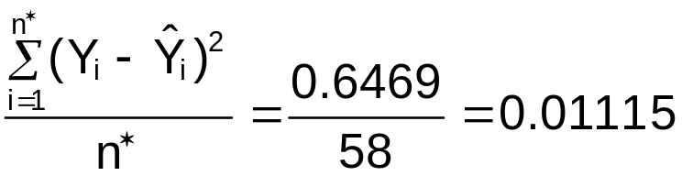

There is an increase in mean prediction error of
(0.01115 – 0.00714) / 0.00714 = 56.21%.

Note that there generally always will be an increase from MSE to MSPR. It is hard to say if the increase above is small or large (although I would lean toward saying large).

Below is R code and output to examine the semi-studentized residuals for the validation data set.

> #Examine semi-studentized residuals
> semistud.resid<-(nba.98.99$PPM – pred.98.99) /
sum.fit$sigma
> plot(x = 1:nrow(nba.98.99), y = semistud.resid, xlab =
"1998-9 Observation number", ylab = "Semi-studentized
residuals", main = "1998-9 Semi-studentized residuals",
panel.first = grid(col = "gray", lty = "dotted"), ylim
= c(min(-3,semistud.resid), max(3,semistud.resid)))
> abline(h = 0, col = "darkgreen")
> abline(h = c(-3,3), col = "red", lwd = 2)
> identify(x = 1:nrow(nba.98.99), y = semistud.resid)
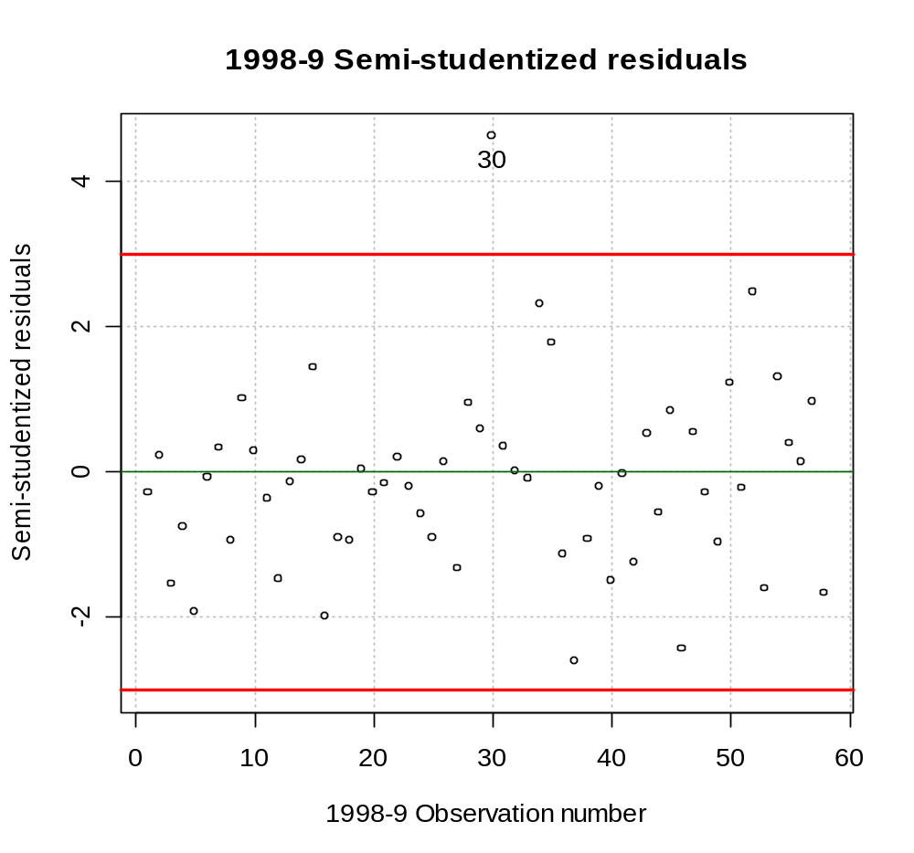

> nba.98.99[30,]
last.name first.name PPM MPG height FTP FGP age
30 Johnson Eddie 0.67 6 201 0 46.2 40.42

Note that Eddie Johnson only played in 3 games! (http://looksmart.infoplease.com/ipsa/A0778235.html). The model is also being used to predict outside the range of the data available for the 1992-3 data set (largest age is 37 for Cheeks). In the 1998-9 data set, there are two players (includes Eddie Johnson) greater than 37 years of age.

When these observations are removed:

> mod.fit.98.99.2<-lm(formula = PPM ~ MPG + height + FGP +
age + I(MPG^2) + MPG:age, data =
nba.98.99[nba.98.99$age<=37,])
> summary(mod.fit.98.99.2)

Call:
lm(formula = PPM ~ MPG + height + FGP + age + I(MPG^2) + MPG:age, data = nba.98.99[nba.98.99$age <= 37, ])

Residuals:
Min 1Q Median 3Q Max
-0.20546 -0.05827 0.00671 0.05083 0.22890

Coefficients:
Estimate Std. Error t value Pr(>|t|)
(Intercept) 0.1527547 0.5100386 0.299 0.765828
MPG -0.0362326 0.0097780 -3.706 0.000537 ***
height 0.0019472 0.0019811 0.983 0.330487
FGP 0.0125480 0.0020484 6.126 1.50e-07 ***
age -0.0192197 0.0093302 -2.060 0.044736 *
I(MPG^2) 0.0004331 0.0001431 3.027 0.003931 **
MPG:age 0.0006482 0.0003433 1.888 0.064907 .
---
Signif. codes: 0 '***' 0.001 '**' 0.01 '*' 0.05 '.' 0.1 ' ' 1

Residual standard error: 0.09406 on 49 degrees of freedom
Multiple R-Squared: 0.6287, Adjusted R-squared: 0.5832
F-statistic: 13.83 on 6 and 49 DF, p-value: 4.015e-09

> #Relative change in estimated beta's
> round((mod.fit.98.99.2$coefficients-mod.fit$coefficients)
/mod.fit$coefficients,4)
(Intercept) MPG height FGP age
-1.5755 -0.0804 -0.5961 0.1454 -0.1561

I(MPG^2) MPG:age
0.0957 -0.2594

> pred.98.99.2<-predict(object = mod.fit, newdata =
nba.98.99[nba.98.99$age<=37,])
> mspr<-sum((nba.98.99[nba.98.99$age<=37,]$PPM –
pred.98.99.2)^2)/nrow(nba.98.99[nba.98.99$age<=37,])
> mspr
[1] 0.00881626

Term | 1992-3’s b_{i} | 1998-9’s b_{i}  Age <= 37 | % Change
Intercept | -0.2654 | 0.1528 | -157.57%
MPG | -0.0394 | -0.0362 | -8.12%
Height | 0.0048 | 0.00195 | -59.38%
FGP | 0.0110 | 0.0126 | 14.55%
Age | -0.0228 | -0.0192 | -15.79%
MPG∗Age | 0.0008752 | 0.0006482 | -25.94%
MPG² | 0.0003953 | 0.0004331 | 9.56%
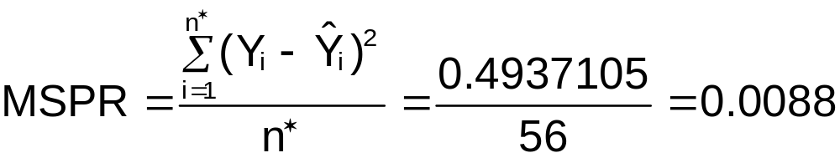
The MSE from the 1992-3 data set is 0.00714. There is an increase in mean prediction error of (0.00882 – 0.00714) / 0.00714 = 23.48%.

Example: NBA guard data (NBA_ch10_validation.R)

At the beginning of the model building process, the data set could have been split into model building and validation data sets. The model building data set would have been used to construct the model (Chapters 9-10), and the validation data set would be used to test the model out. This whole process is not illustrated here, but the code below shows how to split the data. The model building data set contains approximately 80% of the data, and the validation data set contains approximately 20% of the data.

> #Sample 105 observations from uniform(0,1)
> set.seed(9192)
> unif.split<-runif(n = nrow(nba), min = 0, max = 1)

> nba.model.build<-nba[unif.split <= 0.8, ]
> nba.validation<-nba[unif.split > 0.8, ]

> head(nba.model.build)
last.name first.initial games PPM MPG height FTP FGP age
2 Adams M. 69 0.4086 36.2174 178 85.6 43.9 30
3 Ainge D. 81 0.4419 26.7037 196 84.8 46.2 34
4 Anderson K. 55 0.4624 36.5455 185 77.6 43.5 23
5 Anthony G. 70 0.2719 24.2714 188 67.3 41.5 26
7 Bagley J. 10 0.2371 9.7000 210 83.3 36.0 33
10 Battle J. 41 0.4455 12.1220 188 77.8 41.5 31
> nrow(nba.model.build)
[1] 85

> head(nba.validation)
last.name first.initial games PPM MPG height FTP FGP age
1 Abdul-Rauf M. 80 0.5668 33.8750 185 93.5 45.0 24
6 Armstrsong B.J. 81 0.3998 30.7654 188 86.1 49.9 26
8 Barros D. 70 0.4393 17.7571 180 83.1 45.1 26
9 Barry J. 46 0.3667 12.0000 196 67.3 36.9 24
11 Bennett T. 74 0.3195 11.5811 183 73.2 42.3 24
13 Blaylock M. 80 0.3801 35.2500 185 72.8 42.9 26
> nrow(nba.validation)
[1] 20

The model building process would now start from the beginning using the nba.model.build data set ONLY. The nba.validation data set would not be examined until the model validation (Section 9.5) begins.

Review: Let X be a random variable on the interval [A,B]. The uniform probability distribution function (PDF) is

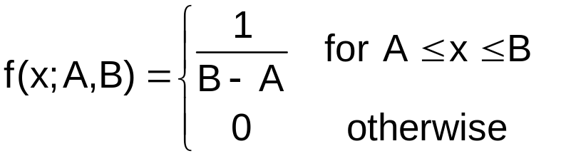

Notes:
- The parameters, A and B, control the location of the PDF. In general, this is what a graph of the PDF looks like.
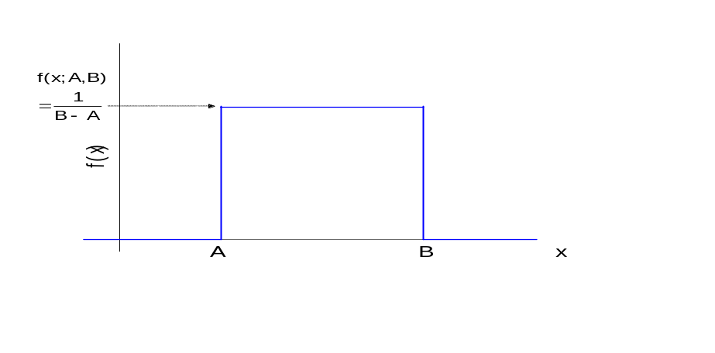
- The area under the “curve” is 1. Since the PDF looks like a rectangle, we can take base∗height =
(B-A)∗[1/(B-A)] to find the area is 1.

